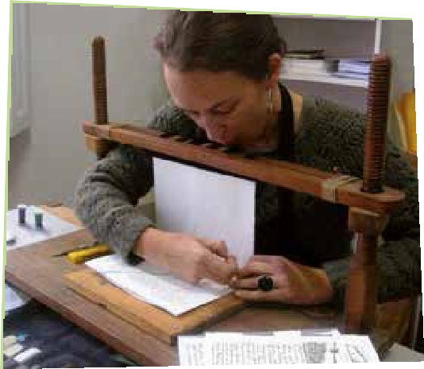
BOOKBINDER

- You love BOOKS
- You RESTORE COVERS of old
books and make new covers for new books
- You work in an ATELIER

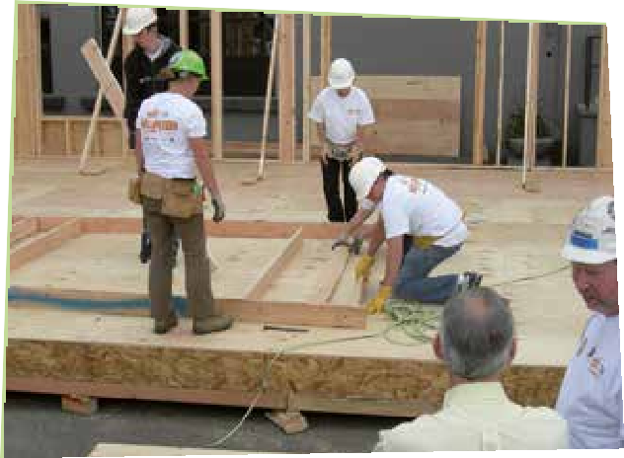

DECOR- and STAND BUILDER

- You build a DECOR from a movie of TV-show
- You help build a LARGE STAGE OR INFO STANDS
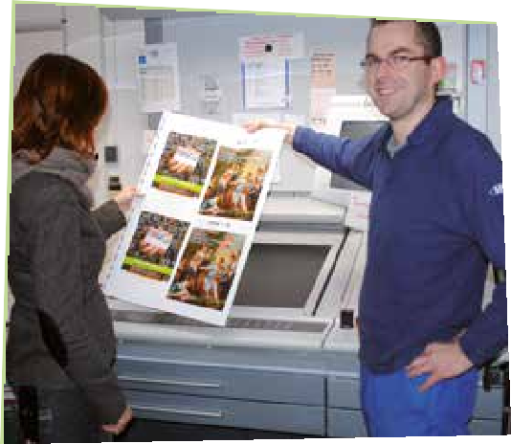
PRESSMANN
- You are BUSY BUSY BUSY BUSY BUSY
- You make sure that everything is PRINTED, such as the pictures on the advertising in your bus
- You can work with PICTURES on you COMPUTER
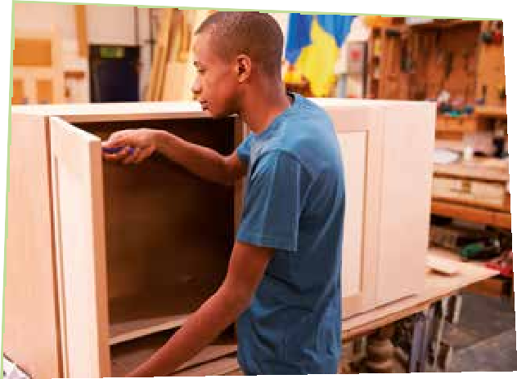
INTERIOR BUILDER

- You are very HANDY
- You place KITCHENS, BATHROOMS AND
CEILINGS
- You work with MACHINES, PAINT AND WOOD
- You usually work INSIDE

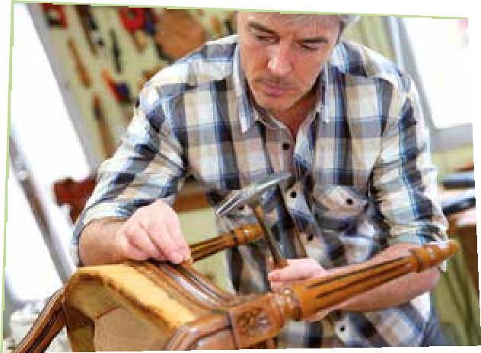
FURNITURE UPHOLSTERER

- SEATS AND CHAIRS get a beautiful UPHOLSTERY thanks to you
- You are great with machines and you are HANDY
- You can work in a
FACTORY but also in a small ATELIER

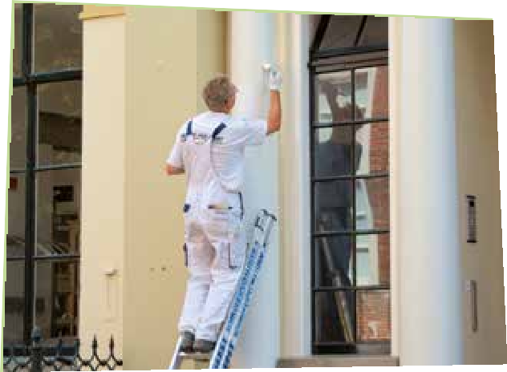
PAINTER-DECORATOR

- You like PRETTY ROOMS
- You can PAPER, PAINT AND LAY FLOORS
- You can’t have FEAR OF HEIGTHS

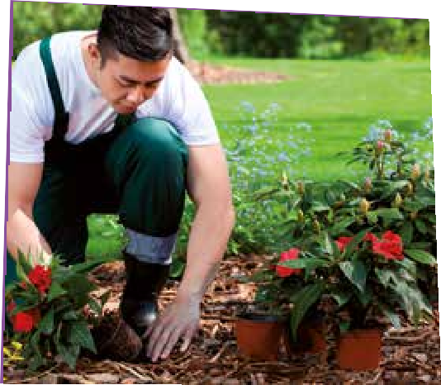
HORTICULTURAL WORKER

- You breed VEGETABLES, FRUIT, FLOWERS AND TREES
- You work OUTSIDE or in a CONSERVATORY

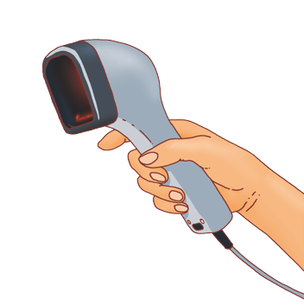

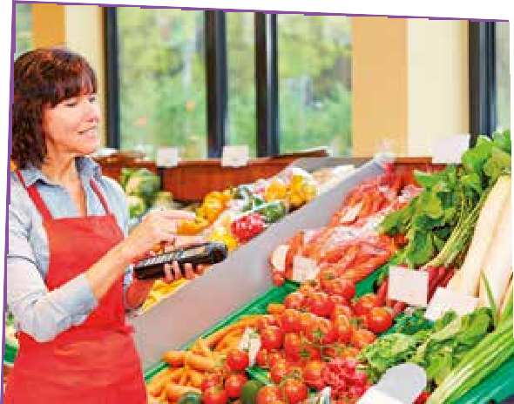
STORE HELP

- You FILL RACKS
- You HELP people find their groceries and make sure they are SATISFIED
- You ensure that the CASH REGISTER is correct

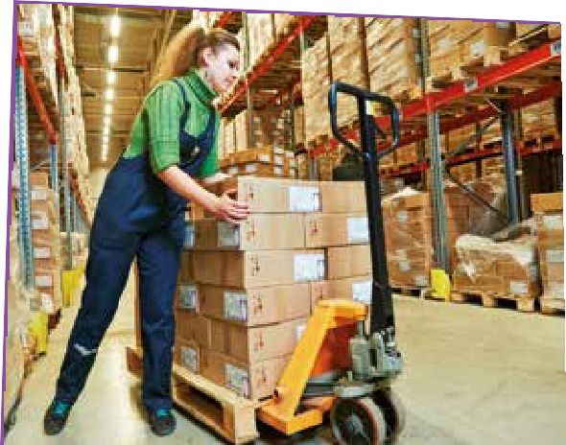

WAREHOUSE WORKER

- You work in a big STORAGE
- You make sure everybody gets the right PACKAGE
- You put all the material in THE RIGHT PLACE

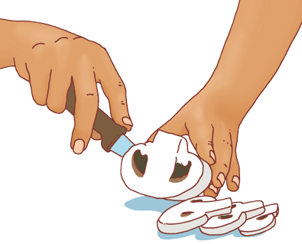

BAKER

  - You bake the best BREAD
and the prettiest
CAKES
  - You learn how to make DOUGH AND BATTER and how the MACHINES work in the bakery

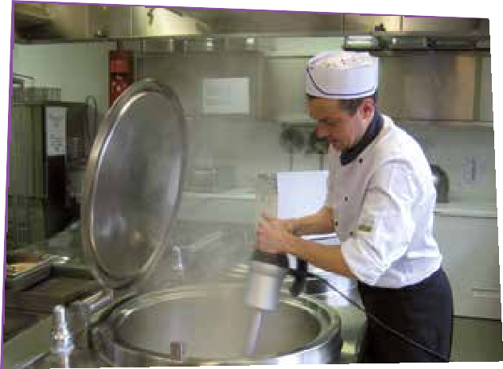

LARGE KITCHEN EMPLOYEE

- You work in a LARGE KITCHEN of a school,
company or hospital

- You make sure a lot of people get FOOD

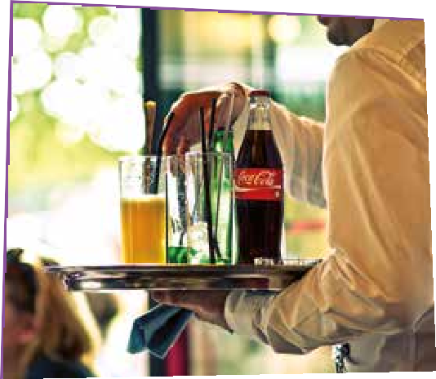
WAITER

- You like to receive guests
- You are more of an EVENING- than a morningperson
- You SERVE people in a
BAR or RESTAURANT in an elegant suit
- You have to be able to WRITE and CHECKOUT accurately

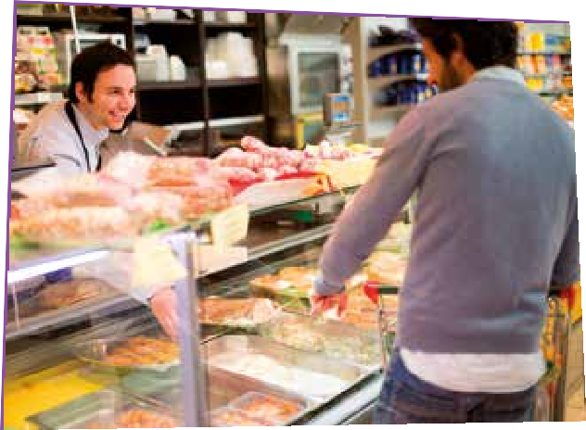
BUTCHER

- You like MEAT
- You work with
DANGEROUS KNIFES
- You know how to STORE meat

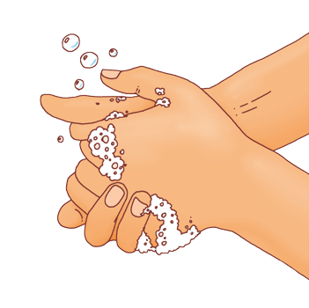

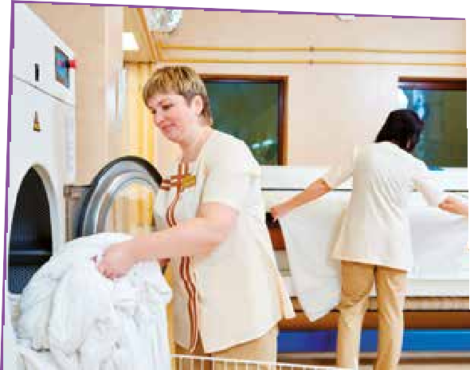
LAUNDRY OPERATOR

- You work in a LAUNDRY
ROOM
- You operate large IRONERS
- You make sure all STAINS AND WRINKLES dissapear
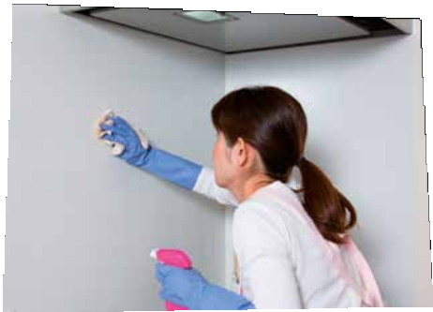

CLEANING AID AT HOME

- You work IN SOMEONE ELSE’S HOME
- You make sure the FLOORS and WINDOWS are clean

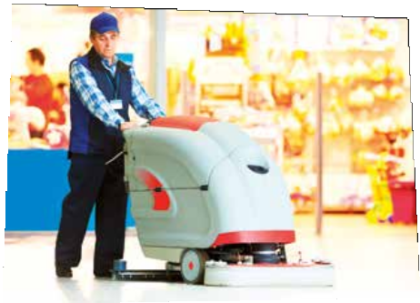
  - You work in FACTORY’S, HOSPITALS AND STATIONS
  - You make sure everything is CLEAN AND SAFE
  - You can work with large MACHINES and insert the correct CLEAN PRODUCTCLEA
CLEANER LARGE SPACES

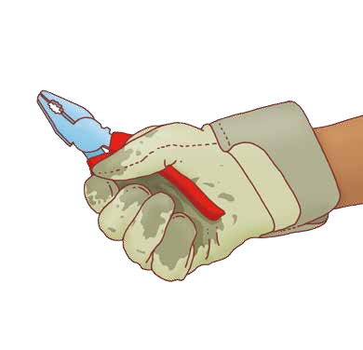

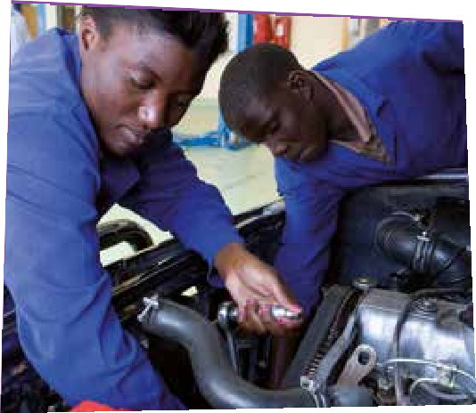

CAR ASSISTANT

  - You like CARS
  - You mainly work on the OUTSIDE of the car, you remove SCRATCHES after an accident and make the car shine again.

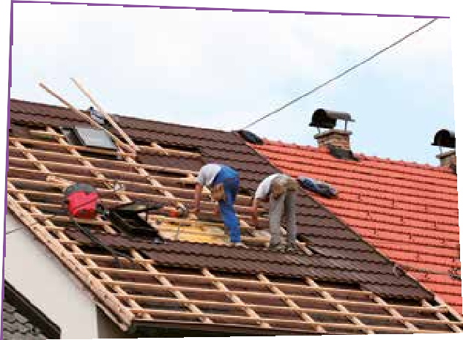
ROOFWORKeERROOFWORKERER
ROOFWORKER

- You install and repair ROOFTOPS
- You always work OUTSIDE and have a nice view
- You DON’T HAVE FEAR OF HEIGHTS

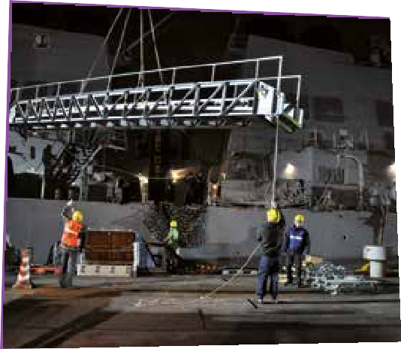
DOCKER

  - It’s a job at the WATER
  - You see people from all countries
  - You help with the UNLOADING AND LOADING of the CONTAINERS

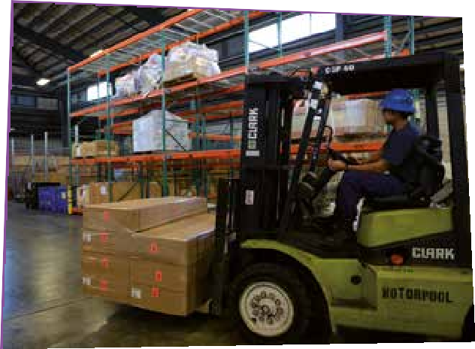
FORKLIFT DRIVER

- You work in a large STOCKROOM
- You drive a FORKLIFT TRUCK
- You STACK the material in the right place

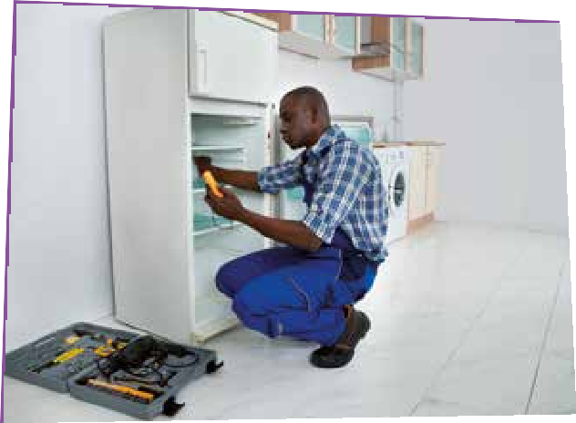

HANDYMAN OR -WOMAN

  - You are HANDY and like doing CHORES like repair stuff, paint and working in the garden
  - You are a saviour for people that are not handy

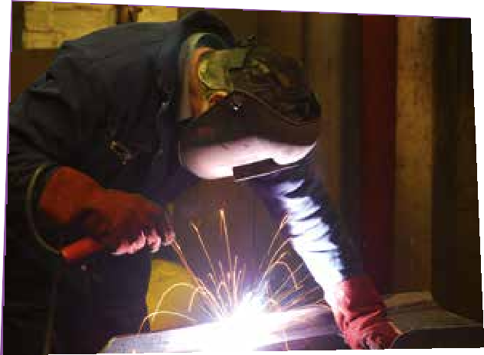
WELDER

* You make CONSTRUCTIONS in
metal, eg boats, fences, cars,
bicycles and even works of art

* You work in FACTORIES OR
ATELIERS

* You are STRONG AND AGILE because you sometimes have to lift or crawl under machines

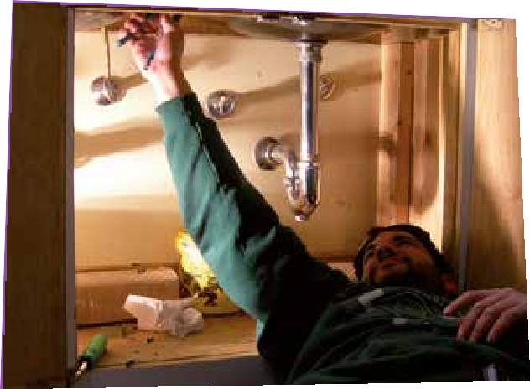
PLUMBER

- You install TOILETS, SINKS AND HEATING
- You REPAIR leaking cranes and broken toilets

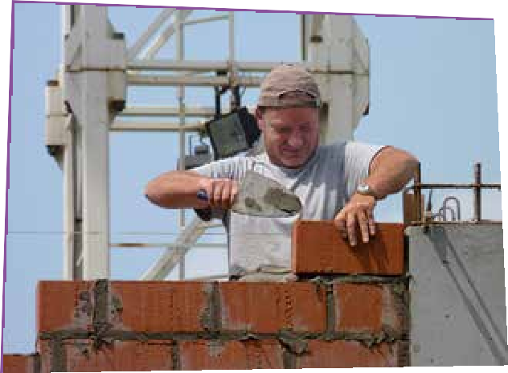
BRICKLAYER

- You built WALLS with bricks
- You LIFT heavy things
- You work OUTSIDE

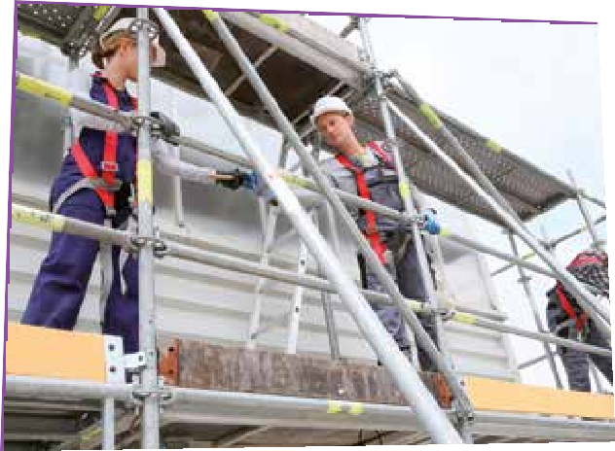
SCAFFOLD BUILDER

  - You DON’T HAVE FEAR OF HEIGHTS
  - You are STRONG AND HANDY
  - You work in CONSTRUCTION
  - You help building tribunes for football-games

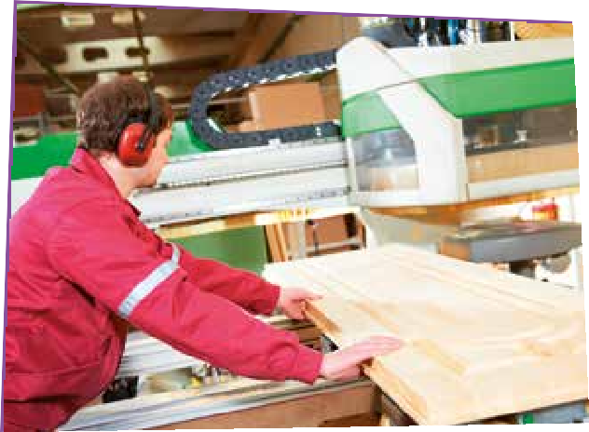

WORKPLACE WRITER

  - You like the smell of WOOD
  - You make WINDOWS, DOORS AND STAIRS
  - You’re good at MEASURING AND MATH so the doors and windows fit perfectly

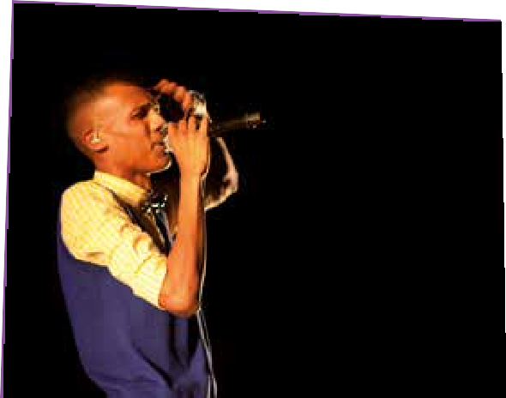
FAMOUS

- You have a SPECIAL TALENT
- You have a GOLDEN VOICE
- You are a great DANCER
- You feel great at a STAGE
- Or you are EXTRAORDINARY at sports

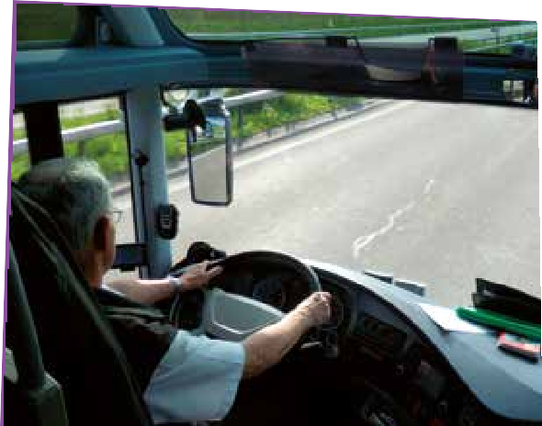
DRIVER
- You like being INDEPENDANT AND ON THE ROAD
- You like driving a BUS OR TRUCK
You also know something about TECHNOLOGY
AND MAINTENANCE of a bus or truck
- Thanks to you, everyone arrives at his destination ON TIME
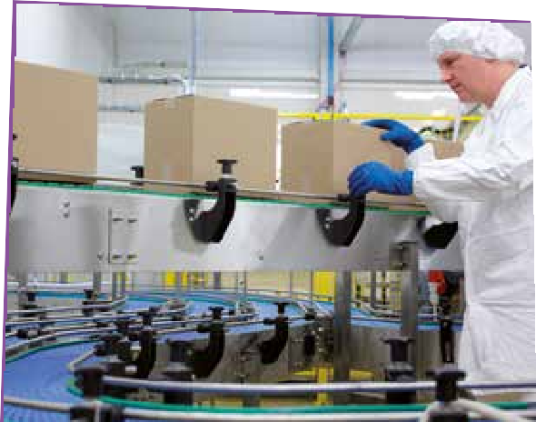
PACKER
- You like REGULARITY and regular tasks
- You like to know in advance how your day will look like
- You work in a FACTORY OR WORKPLACE
- You are HANDY and you can concentrate well
- Without you, the stores would be empty

COURIERR
- You deliver SMALL PACKAGES, IMPORTANT LETTERS OR MEDICATION to people or company’s
- You drive around in a CAR OR CAMIONETTE
- You have insight on the TRAFFIC
- You like driving with a car of bisycle and like CONTACT WITH CLIENTS
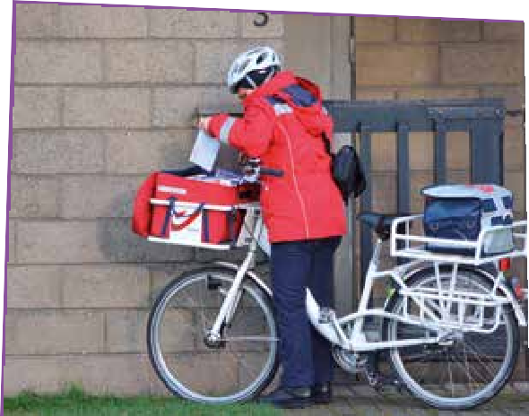
MAILMAN

  - You are ALWAYS ON THE ROAD; with a bicycle, hummer or car
  - You are in good condition and like to be among people
  - You like to get up EARLY and enjoy the OUTDOOR AIR
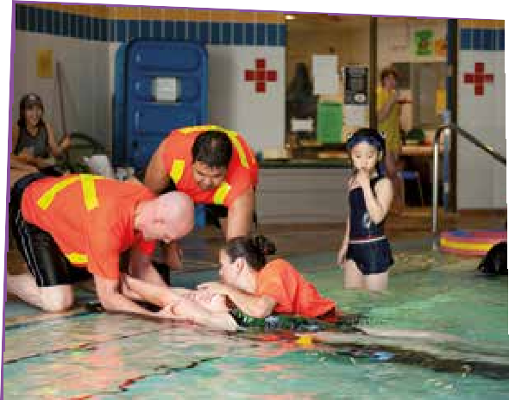
LIFEGUARD

- You supervise the POOL
- You can administer FIRST AID
- You make sure everybody sticks by the RULES
- You are in GOOD CONDITION
- You are STRICKT AND RESOLUTE, in a friendly way

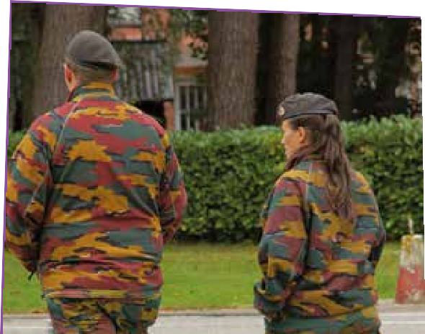
SOLDIER

- You DEFEND the fatherland
- You have a feel for RESPONSIBILITY, You have an excellent CONDITION, DISCIPLINE and can work well with others
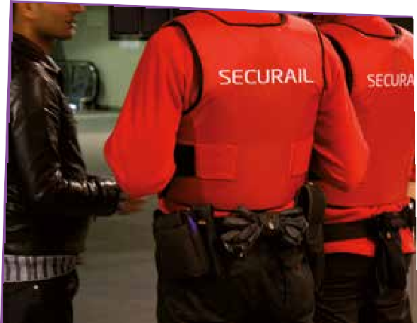

- You like HELPING others to keep the society PLEASANT AND SAFE
- You are good at dealing with people, you are at peace with conflicts and quarrels and you have a GOOD CONDITION
SECURITY, STEWARD OR CITY GUARD

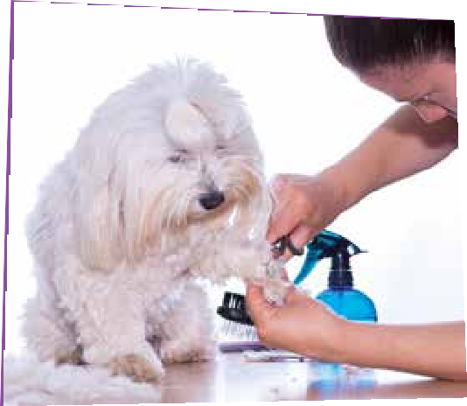
ANIMAL TRIMMER

  - You love DOGS AND CATS
  - You like CUTTING their nails
  - You WASH their fur and know which PRODUCTS you have to use
  - You can COMFORT the animals and their owners
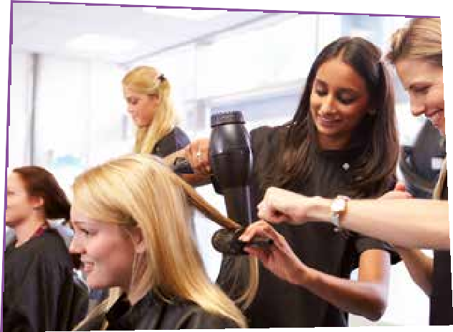
HAIRDRESSER

    - You like to make the HAIR of other people beautiful
    - You can WASH, COLOR AND DRY hair
    - You like talking to CUSTOMERS

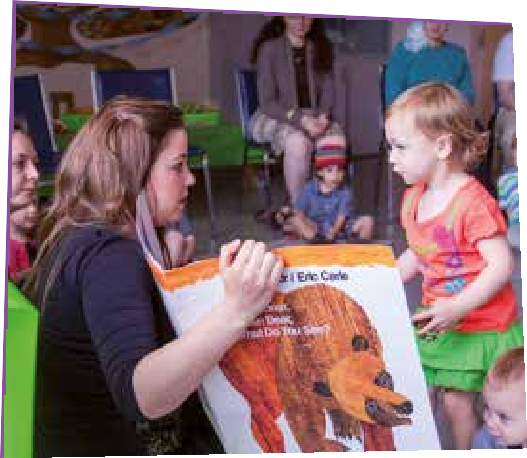
CHILDCARE WORKER
  - You like taking care of SMALL CHILDREN
  - You GUIDE children on the bus
  - You help the kindergarten teacher
  - You think of games for on the playground
  - You are SWEET, RESPONSIBLE AND CREATIVE
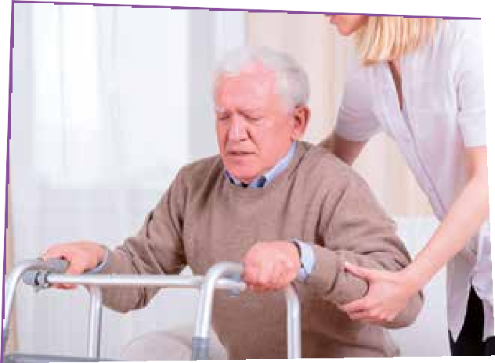
LOGISTIC ASSISTENT

    - You transport PATIENTS
    - You give the right
MEDICIN to the right person
    - You work in a REST HOME OR HOSPITAL

