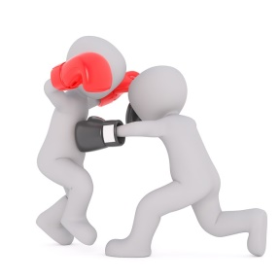
Conflicts
How do you react to conflicts?

Method to deal with conflicts | I use this method |  |  | I find this method
 | Often | Some  times | Not  much | Good | Alright | Not good
You immediately start swearing.

You avoid the person and postpone a conversation.

You are looking for a solution that everyone is happy with.

You explain to the other person what is bothering you.

You ask someone else to help resolve the fight.

You agree with the other.

You are angry and use physical violence.

You try to understand why the other person thinks differently.

You act like there is no problem.

You keep talking to the other person until he admits.
You put the problem into perspective: is it worth a fight?

