TV guide Worksheet

Find:
What is playing on “FOX” channel at 9:00pm? ________________________________________ What time does this show finish? ____________________
What is playing on “PBS” channel at 10pm? ________________________________________ What time does this show finish? ____________________
What time is “Spin the Wheel” on? ___________________________________________ On which channel? ____________________________

TV guide Worksheet

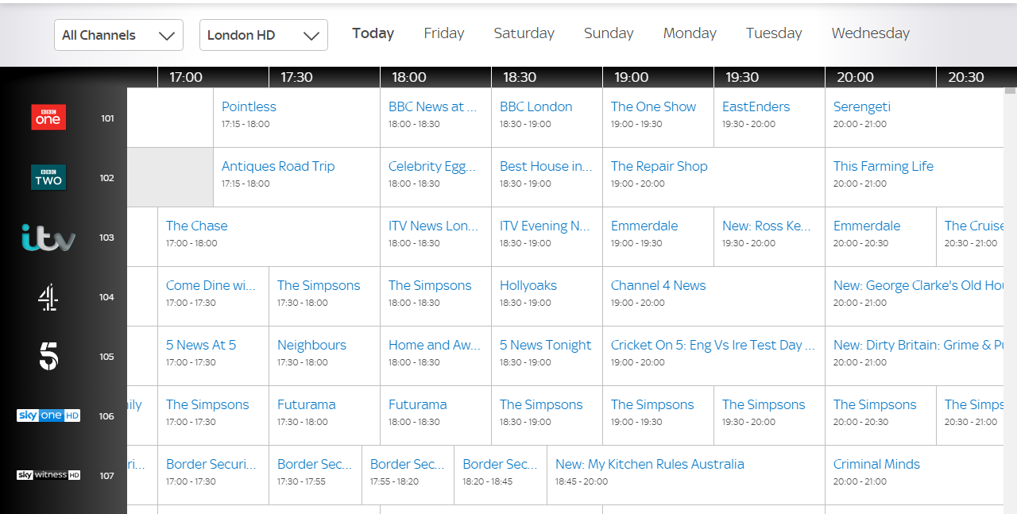

Find:
What is playing on “BBC TWO” channel at 19:00pm? ________________________________________ What time does this show finish? ____________________
What is playing on channel “5” at 17:30pm? ________________________________________ What time does this show finish? ____________________
What time is “The Simpsons” on? ___________________________________________ On what channel? __________________________

TV guide Worksheet

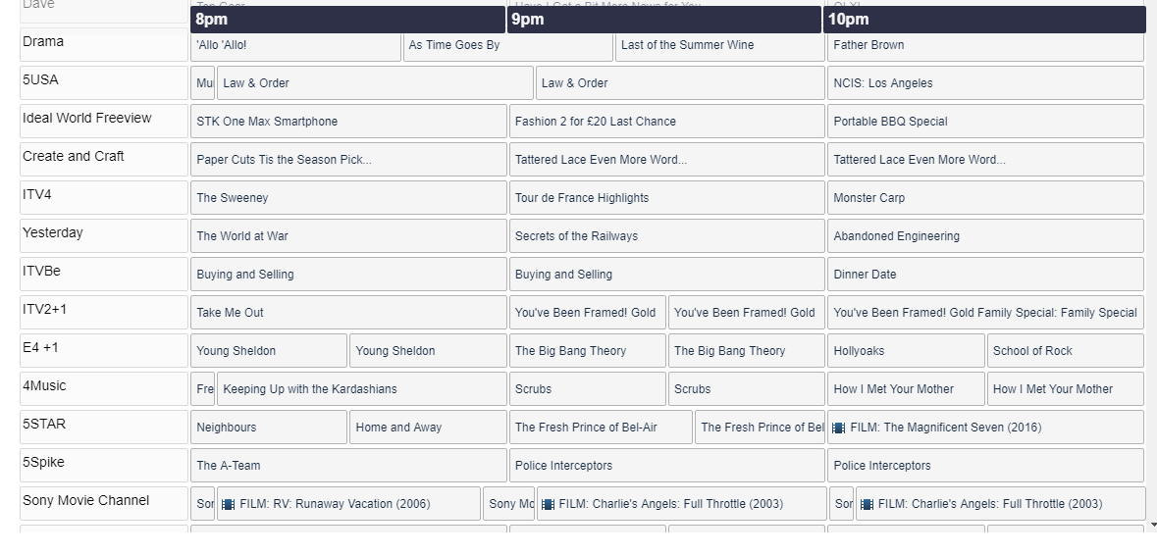
Find:
What is playing on “Yesterday” channel at 9pm? ________________________________________
What is playing on “5Spike” channel at 8pm? ________________________________________
What two movies are playing at 10pm? ___________________________________________ and ______________________________________________

