LEISURE 2c - TV Remote Control Basic Use

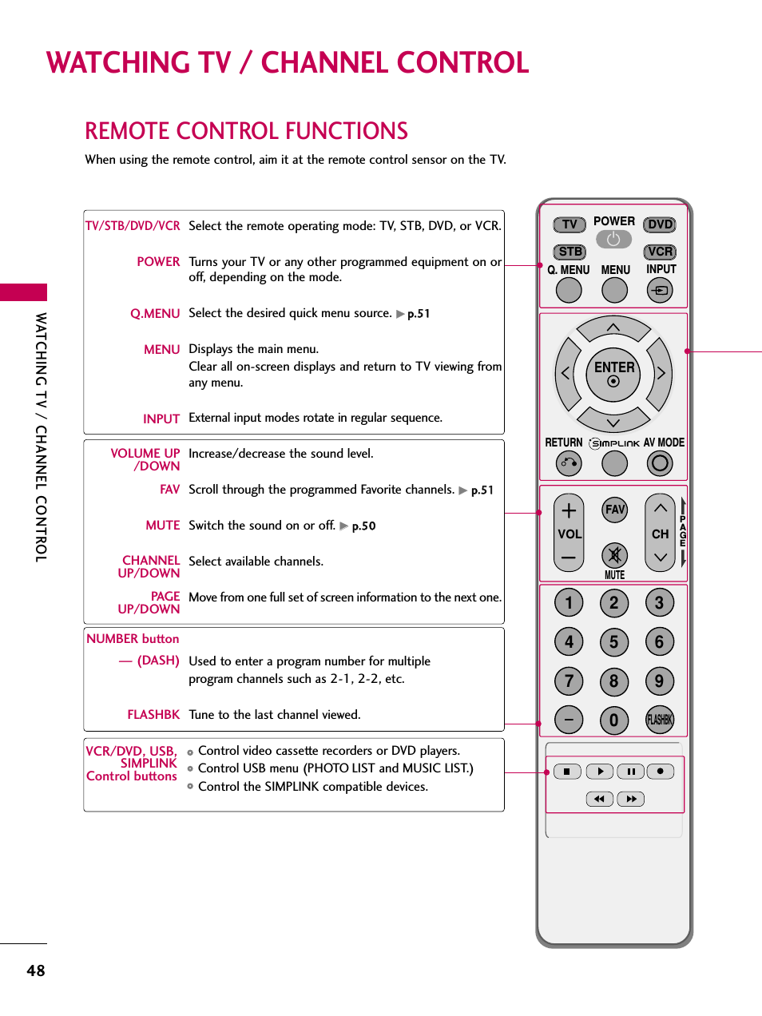

LEISURE 2c - TV Remote Control Symbols & Use (worksheet on next page)
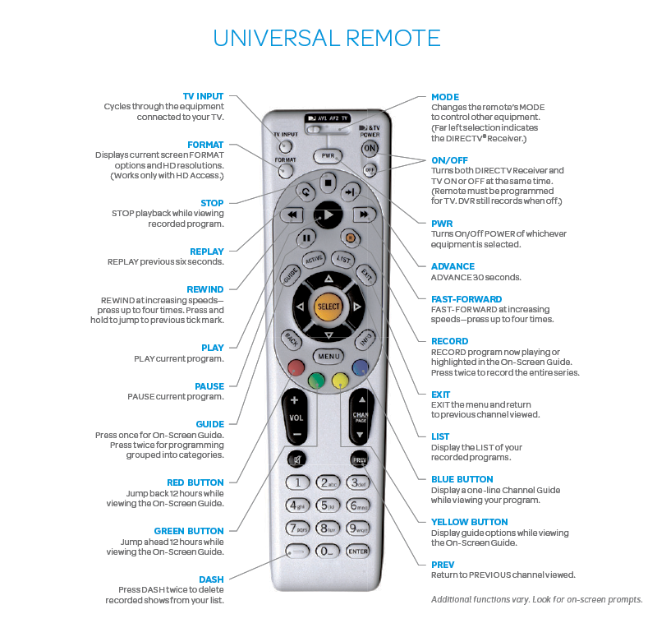
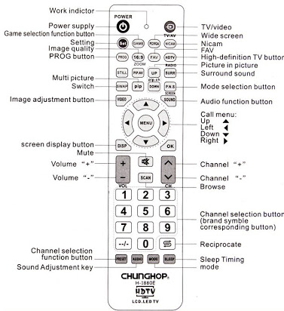

Worksheet 2c
Find the common buttons on the two remote controls.
Comment on the different buttons.
Choose one from the following list, read it, find it on the remote and explain its use:

power on/off pause rewind
channel forward volume fast forward
sleep timing record menu play
up exit down list
left right preview stop

WORKSHEET - MP3 player control symbols
Write the word under the correct symbol.

repeat play pause next track volume
previous track shuffle mute stop

__________ ________ ________ _________ ________ ________ _________ __________ _______
_________ ________

